**CHAPTER 1**

**ALERTING FOREST FIRE USING WIRELESS SENSORS**

* 1. **INTRODUCTION**

A Forest fire is an uncontrolled fire in an area of combustible vegetation that occurs in the countryside or in forest area. India witnessed the most severe forest fires in the recent time during the summer of 1995 in the hills of Uttar Pradesh and Himachal Pradesh. The Forest Survey of India’s data on forest fire attributes around 50% of the forest areas as fire prone. They pose a threat not only to the forest wealth, but also to the entire regime of fauna and flora, seriously disturbing the bio-diversity, ecology and the environment of a region. During summer, when there is no rain for months, the forests become littered with dry senescent leaves and twinges, which could burst into flames ignited by the slightest spark. The Himalayan forests, particularly, Garhwal Himalayas have been burning regularly during the last few summers, with colossal loss of vegetation cover in that region. Forest fires often start unnoticed and spread very quickly, causing millions of dollars in damage and claiming many human lives every year in the many countries. Early detection of hot spots and the initiation of appropriate measures can prevent, or, at least minimize damage and casualties. Common causes of forest fires are lightning, extreme hot and arid weather, severe drought, and human unawareness. Current satellite-imagery-based forest fire detection systems cannot detect forest fires with high precision and accuracy. A Wireless sensor network-based forest fire detection system has the potential to achieve the high detection resolution and accuracy that is required for early detection of forest fires.

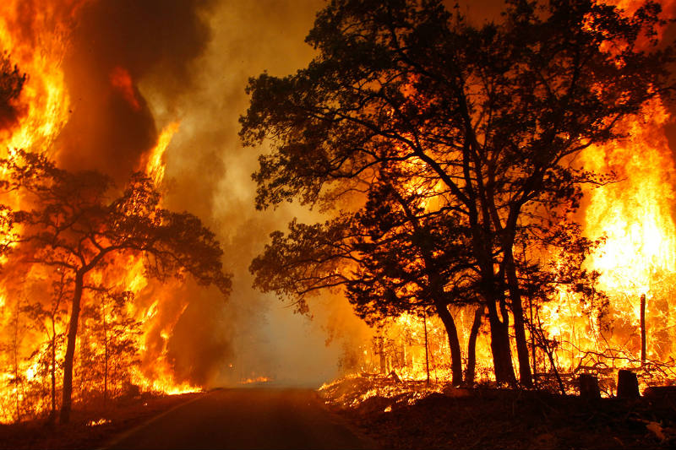 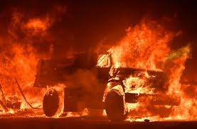

**Figure 1.1: Destruction of the forest due to forest fire at California**

 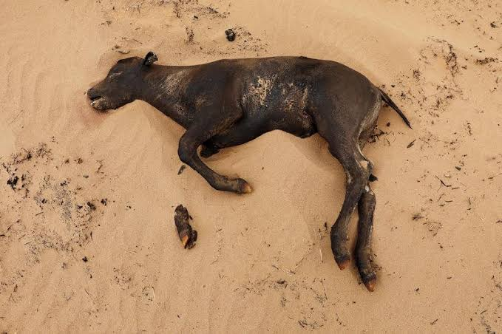 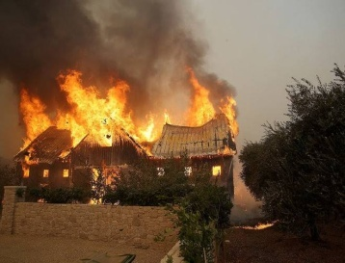

**Figure1.2: Loss of wild life due to forest fire in California**

The 2018 wildfire season is the most destructive wildfire season on record in California, with total of 7,579 fires burning an area of 1,66,7,855 acres (674,957 ha), the largest amount of burned acreage recorded in a fire season, according to the California Department of Forestry and Fire protection(cal fire) and the National Interagency Fire Center(NIFC), as of November 11. The fire have caused more than $1.366 billion in fire suppression costs. Through the end of August 2018, cal fire alone spent $432 million on operations. The Mendocino complex fire burned more than 459,000 acres becoming the largest complex fire in the state’s history, with the complex’s Ranch Fire surpassing the Thomas Fire and the Santiago Canyon Fire of 1889 to become California’s single-largest recorded wildfire.

**1.2 OBJECTIVES**

* Forest fire is an uncontrolled fire occurring in nature. Once the fire starts ignited it rapidly spreads all over area in the forest. Forest fire spreads on hot summery day when drought conditions peak, something as small as a spark from a train cars wheel striking the track can ignite a raging wildfire. This could result in massive destruction.
* This project is to detect forest fire and provides alert to authorized person to avoid property loss.
* Adriano software based AVR Microcontroller is used as master control for fire detection, data acquisition and information sending process.
* GSM based wireless protocol is implemented here for online data monitoring applications.

**1.3PROPOSED SYSTEM**

* In this Model proposed system has two tasks i.e. collecting data from sensors and another one is sensor network data utilization for timely alerting authorized person.
* The goal of sensor data interpretation, particularly using data fusion techniques, is to increase the reliability and reduce the chances of false alarm.
* In this project arm fire is detected by the fusion of data from sensors.
* Combining sensors for collecting data and advanced algorithms for data processing and interpretation, more advanced object called the observer could be designed.
* When an observer network could be established, capable for better understanding what is going on in sensors surroundings. In such a way an advanced early warning system for initial phase fire hazards detection could be designed.

**1.4PROBLEM DEFINITION**

* As we all know, the forest is considered as one of the most important resources and Forest fires represent a constant threat to ecological systems.
* It always start by one of two ways : naturally caused / human caused.
* Natural fires generally started by lightning, with a very small percentage started by spontaneous combustion of dry fuel such as sawdust and leaves.
* On the other hand, human-caused fires can be due to any number of reasons.
* By this there may destruction of wildlife, trees. Polluting the air with emissions of harmful gases.
* Fire also releases Co2, a key greenhouse gas into atmosphere.
* Hence, The Forest fire detection and alerting is very important issue.
* The powerful feature of wireless network is to challenge of early detection of forest fire.

**CHAPTER 2**

**LITERATURE SURVEY**

**L Yu, et.al.,“Forest Fire Detection using Wireless Sensor”**

This Paper Presents that With the advancement in human technology the risk of natural and man induced catastrophes increased exponentially. One of most dangerous disaster is forest fire. The forest fire represents continuous threat to species of flora as well as fauna. This paper highlights the powerful feature of wireless sensors for forest fire detection. The sensor data is collected using Arduino development board and transmitted to base station wirelessly. Also an alert is send using GSM module.

**D V Kirubaharan, et.al., “Forest Fire Prediction and Alert System Using Wireless Sensor Network”**

This Paper presents that As humans advanced in technology, manmade and natural disasters are increasing exponentially. One of the most dangerous is the forest fire. Forest fire destroys trees which give us oxygen and it is very difficult to stop a forest fire spreading if it is not detected early. Our method is to detect the forest fire as early as possible and also predict the forest fire in advance so that prompt action can be taken before the fire destroys and spreads over a large area. The proposed method senses temperature from all over the forest and sends this data for processing. The direction in which the fire spreads is found and the rate of spread is calculated to take quicker action.

**Chi Yuan, et.al., “A survey on technologies for automatic forest fire monitoring, detection, and fighting using unmanned aerial vehicles and remote sensing techniques****”**

This Paper presents that Because of their rapid maneuverability, extended operational range, and improved personnel safety, unmanned aerial vehicles (UAVs) with vision-based systems have great potential for monitoring, detecting, and fighting forest fires. Over the last decade, UAV-based forest fire fighting technology has shown increasing promise. This paper presents a systematic overview of current progress in this field. First, a brief review of the development and system architecture of UAV systems for forest fire monitoring, detection, and fighting is provided. Next, technologies related to UAV forest fire monitoring, detection, and fighting are briefly reviewed, including those associated with fire detection, diagnosis, and prognosis, image vibration elimination, and cooperative control of UAVs. The final section outlines existing challenges and potential solutions in the application of UAVs to forest firefighting.

# Yingli Zhu, et.al., “Monitoring system for forest fire based on wireless sensor network”

This Paper states that The forest is considered as a precious and indispensable nature resource, but forest fire which can destroy forest resource safety and threaten human-living environment is considered as one of the severest disasters. How to monitor and collect information of forest fire at any time, it is a difficult problem for Forest Fire Prevention Departments to urgently solve. With the development of sensor technology, MEMS and wireless communications, wireless sensor network (WSN) has wide application in all kinds of fields. In order to prevent forest fire occurrence, this paper designs a monitoring system for forest fires based on wireless sensor network and GPRS network. The system gives the hardware design of wireless sensor nodes and software implementations, and chooses CC2531 to achieve the process of data acquisition and transmission, then sends the data through GPRS module to the remote monitoring center. By means of WSN and GPRS network, the system accomplishes data acquisition and long distance transmission.

**W Tan, et.al.,**[**“Mine Fire Detection System Based on Wireless Sensor Network**](https://ieeexplore.ieee.org/document/4295715)**”**

This Paper says that The issue of mine safety is quite outstanding recent years. Many shortages exist in mine safety systems supported by current technologies. The features of wireless sensor network determined that it well adapts the special needs of the environment monitoring. This paper presents the design of a mine safety system based on wireless sensor network which is called WMSS. Considering the unsafe factors under the mine, a sensor network was designed which can gather and analyze the concentration of gas under the mine. Thus, a system for realtime monitoring the environment under the mine is accomplished, and it can also provide the pre-warning for the fire. This paper discussed the components of the system, the topology of the network, hardware and software of the nodes. The software design of the operating system is discussed detailed from the aspect of energy efficient.

**S Liu,et.al.,“**[**Multiparameter fire detection based on wireless sensor network**](https://ieeexplore.ieee.org/document/5358197)**”**

This Paper Presents that Wireless fire detection nodes based on Wireless sensor network is designed which can detect temperature, humidity and smoke concentration. The ratio of fire misinformation is decreased with multiparameter coincidence technique. And a shortest path routing algorithm is proposed according to multi-hop transmission based on CSMA/CA principle. The sensor nodes can connect each other automatically and the sensor data can be transmitted within minimum hops, so a real-time fire monitoring system is built up. The result of experiment show: the maximum distance of single hop transmission is 100 m; the delay time of every hop within multi-hop communications is about 50 ms; the sensitivity of fire smoke reached to I level; the parameter of humidity is used to eliminate the distorted effect of water vapor.

# Zhen He, et.al., “Wireless communication-based smoke detection system design for forest fire monitoring”

This Paper states that Based on wireless communication technology, this paper designs a smoke detection system out of the need for forest fire monitoring. Firstly, this paper designs the hardware scheme for the key functional modules, and implements the integration of the entire system, as well as the functional debugging at the platform. Based on the hardware design, the overall scheme of software system is set up, which successfully gets through the experimental debugging. For communication, the data received from the sensor nodes is collected by a router to a coordinator, and subsequently sent to the GPRS module through a serial port. Finally, the information is shown on the PC through the Internet. The overall system satisfies the particular need of forest environment monitoring, and presents a good prospect of application and promotion.

# D. Antolinet.al.,“Development of a Wireless Sensor Network System for Early Forest Fire Detection”

This paper presents the development of a wireless sensor network system for early forest detection. The proposed application is based on the Low-Rate Wireless Personal Area Network communications standard IEEE 802.15.4. The core hardware and software components of the developed node prototype network for this domain are described: sensor node hardware, microcontroller programming methodologies and networking. Within the implementation strategies, special attention has been paid to reach an appropriate energy handling, essential to achieve long battery life.

**Min wanget.al.,“Forest Fire Warning System Based on GIS and WSNs”**

This Paper presents that Forest fire is caused by burning weeds in the field or burning paper as sacrificial offerings in the graveyard, so that the forest fire early warning system is designed and developed with GIS and WSNs. A number of sensor nodes which constitutes the Wireless sensor networks were developed in the region which can measure the concentration of CO and smog and detect flame and gauge the temperature and humidity. These data including position information are sent to monitor center through the GRPS net and real-time displayed on the electronic map. The level of forest fire monitoring area can be mastered outright by the staff members.

**L Gayng-Hui et.al., “**[**Research on Forest Fire Detection Based on Wireless Sensor Network**](https://ieeexplore.ieee.org/document/1712316)**”**

This Paper states that A comprehensive survey of the up-to-date methods and technologies of forest fire detection and monitoring based on wireless sensor network (WSN) is presented. This paper discusses and analyses the system frame and the key problems of WSN-based forest fire monitoring, it focuses on the forest fire forecast modeling, WSN nodes deployment, WSN nodes and forest fire positioning, transmission control protocol, and the WSN based forest fire detection and alarm system.

**CHAPTER 3**

**METHODOLOGY**

**Working of Block Diagram:**

This project consists of Fire sensors, AVR Microcontroller, LCD Display, Serial Communication Device, GSM Modem, GPS Modem, Alarm Circuit Board and Power supply Board

**SENSOR 3**

**SENSOR 1**

**SENSOR 2**

**MOBILE**

**AVR**

**MICRO**

**CONTROLLER**

**GPS**

**MODULE**

**LCD**

**DISPLAY**

**GSM**

**MODEM**

**POWER SUPPLY**

**ALARM**

**CIRCUIT**

**Figure 3.1: Block Diagram of AVR Microcontroller using GPS,GSM Modem, LCD, Interface and Sensors**

Fire sensors are fixed in different areas of Forest. If any fire found by sensor then sensors send the signals to AVR Master Microcontroller unit. Microcontroller is programmed to display and alert purpose. At the same time it sends the message about fire information with location details authorized person and police control room mobiles phone through GSM Modem. GPS Modem is used to receive location information from satellite.

**3.1 Fire Sensor:**

A fire detectoris a sensordesigned to detect and respond to the presence of a flame or fire*,* allowing flamedetection.

**3.2 AVR Microcontroller:**

AVR Microcontroller is heart of the project. Embedded C language is used to do the programming. The AVR was one of the first microcontroller families to use on-chip [flashmemory](http://en.wikipedia.org/wiki/Flash_memory) for program storage, as opposed to [one-time programmable ROM](http://en.wikipedia.org/wiki/Programmable_read-only_memory), [EPROM](http://en.wikipedia.org/wiki/EPROM), or [EEPROM](http://en.wikipedia.org/wiki/EEPROM) used by other microcontrollers at the time. It support efficient control of home appliances.

**3.3 LCD Display:**.

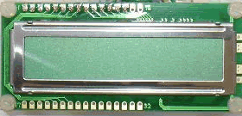

**Figure3.2 : LCD Display**

A **liquid crystal display** (commonly abbreviated **LCD**) is a thin, flat display device made up of any number of color or monochrome pixels arrayed in front of a light source or reflector. It is often utilized in battery-powered electronic devices because it uses very small amounts of electric power.

**3.4 Alarm circuit:**

An Alarm is a signaling device, usually electronic, typically used in automobiles, household appliances such as a microwave oven, or game shows.

**3.5 Global Positioning System (GPS):**

The Global Positioning System (**GPS**) is a network of about 30 satellites orbiting the Earth at an altitude of 20,000 km. Once it has information on how far away at least three satellites are, your GPS receiver can pinpoint your location using a process called trilateration fire . Here GPS Module is used to get forest area location information.

**3.6 GSM Modem:**

A GSM modem is a specialized type of modem which accepts a SIM card, and operates over a subscription to a mobile operator, just like0 a mobile phone. ... When a GSM modem is connected to a computer, this allows the computer to use the GSM modem to communicate over the mobile network. Low Power IOT GSM Modules just configure and play, used for data transparent transmission. SIM900 is highly-integrated UART to GSM module. Users can easily make communication with it among serial device, cellphone and network device.

**CHAPTER 4**

**DESIGN AND IMPLEMENTATION**

**4.1 Flowchart:**A Flowchart is a visual aid to understand the methodology you are using to manage the project.

INITIALIZE THE DEVICE

INCLUDE LCD LIBRARY

SERIAL @ 9600 BAUD RATE

SETUP I/O PORTS

LCD DATA-1

If

PC0 & PC1 & PC5?

DDD

NO NO

PB5=HIGH, LCD DATA-2

SMS EXECUTE MODE

Else if

PC0 &PC1

NO

YES

PB5=HIGH, LCD DATA-3

SMS EXECUTE MODE

PB5=LOW,LCD DATA-5

NO SMS

Else if

PC0?

NONO

PB5=HIGH, LCD DATA-4

SMS EXECUTE

NOTE:

PC0= temperature sensor.

PC1= color sensor.

PC5= smoke sensor.

PB5= fire sensor.

**4.2Circuit Diagram:**

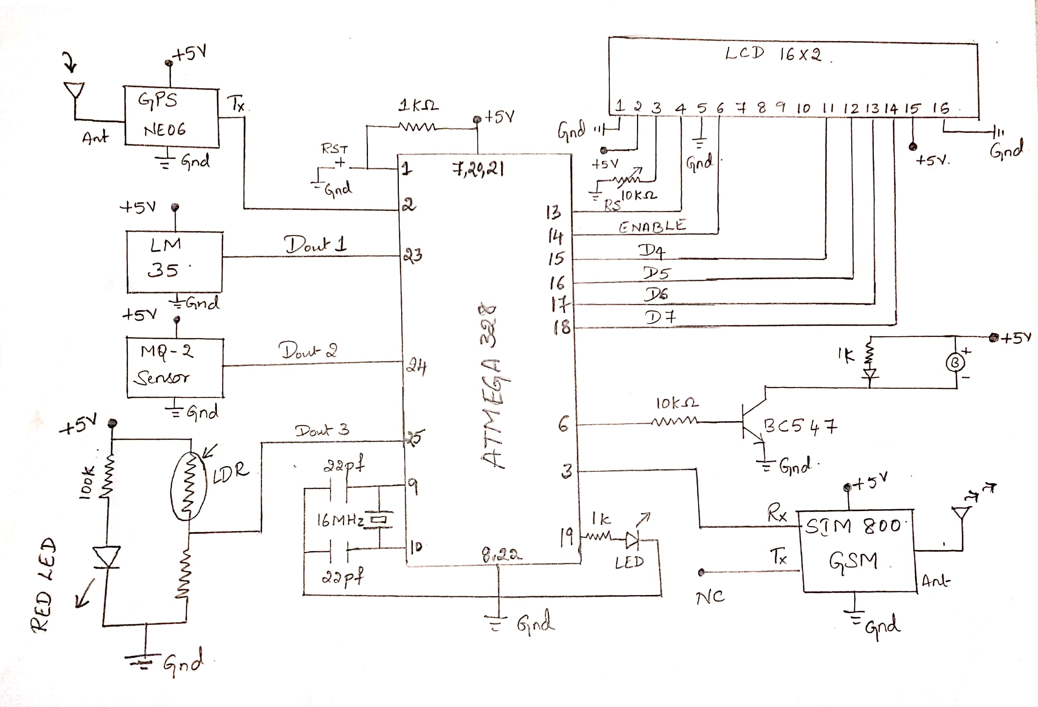

**Figure 4.2: Circuit diagram of forest fire sensor**

Operation:

Automatic fire detection sensors and controlling system for Forest or agriculture fire detection has been designed and demonstrated. The fire detection sensor detects the fire which is received by master or heart of the project the AVR Microcontroller ATMEGA-328 IC. This message is send to the remote area via wireless GSM transceiver & the GPS is used to track the location, here the smart phone is used as remote monitoring area. Then the buzzer or alarm produces beep sound during fire detection for emergency alert. The Embedded C code is written with Arduino OS is open source software using ATMEGA-328 IC. In the future we can add more sensors and can implement more applications on this controller board. AVR Microcontroller ATMEGA-328 is reprogrammable so that we can reprogram the device when we want to modify.

**4.2.1 LM35 Fire Sensor:**

LM35  is a type of commonly used temperature sensor, that can be used to measure temperature with an electrical output comparative to the temperature in (°C). In can measure temperature in a better way then thermistor.LM35 is used in industries and commercial buildings where high accuracy of temperature measuring is needed. I will give you a detailed overview of this temperature sensor in today’s post where we will have a look its pinout, working, protocol, etc. I will also share some links of projects where I have interfaced it with Arduino or other microcontrollers. If you have any question please ask in comments, I will resolve your quires and will guide you in a comprehensive way. So, let’s get started with the basic Introduction to LM35:

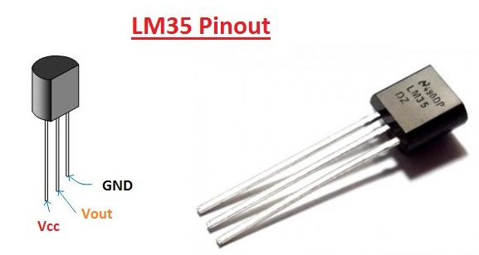

**Figure 4.3: LM35Sensor**

* LM35 is a commonly used temperature sensor, It shows values in the form of output voltages instead of degree Celsius.
* LM35 shows high voltage values than thermocouples and may not need that the output voltage is amplified.
* The output voltage of LM35 is proportional to the Celsius temperature. The scale factor is .01 V/°C.
* One most important characteristic is that it draws just 60 microamps from its supply and acquires a low self-heating capacity.
* LM35 temperature sensor available in many different packages like T0-46 metal transistor-like package, TO-92 plastic transistor-like package, 8-lead surface mount SO-8 small outline package.
* **PIN 1:** Vcc, it used as input at this pin we apply +5 V input voltage.
* **PIN 2:**At this pin, we get output voltage.
* **PIN 3:**This pin is used for ground.
* Here’s the table for LM35 Pinout for better understanding:

|  |  |  |
| --- | --- | --- |
| **No.** | **Parameter** | **Pin Type** |
| 1. | Vcc | Power Pin ( Connected to +5V ) |
| 2 | Vout | Output Pin (It should be connected with an analog pin of Microcontroller) |
| 3 | Ground | Ground Pin ( Connected to 0V or GND ) |

## Table 1: LM35 pinout

## 4.2.2 MQ2 Gas Sensor:

MQ2 is one of the commonly used gas sensors in MQ sensor series. It is a Metal Oxide Semiconductor (MOS) type Gas Sensor also known as **Chemiresistors** as the detection is based upon change of resistance of the sensing material when the Gas comes in contact with the material. Using a simple voltage divider network, concentrations of gas can be detected.MQ2 Gas sensor works on 5V DC and draws around 800mW. It can detect **LPG**, **Smoke**, **Alcohol**, **Propane**, **Hydrogen**, **Methane** and **Carbon Monoxide**concentrations anywhere from 200 to 10000ppm.

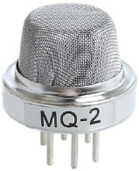

**Figure 4.4: MQ-2 Sensor**

The voltage that the sensor outputs changes accordingly to the smoke/gas level that exits in the atmosphere.The Sensor outputs a voltage that is proportional to the concentration of smoke/ gas.

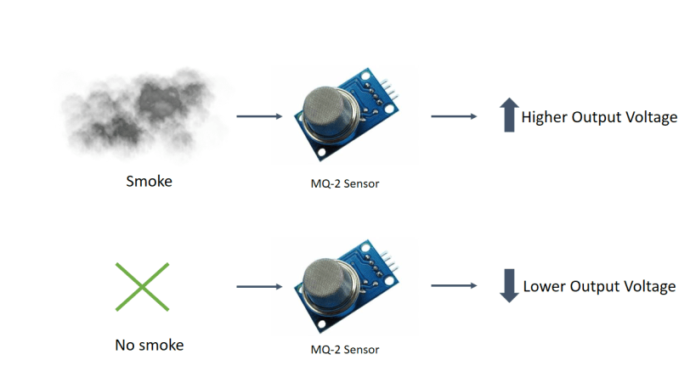

**Figure 4.5: Functioning Of MQ-2 Sensor**

The output can be an analog signal (A0) that can be read with an analog input of the Arduino or a digital output (D0) that can be read with a digital input of the Arduino.

**4.2.2.1 Pin Wiring**

|  |  |
| --- | --- |
| **Pin** | **Wiring to Arduino Uno** |
| A0 | Analog pins |
| D0 | Digital pins |
| GND | GND |
| VCC | 5V |

## Table 2: MQ2 Sensor pin detail

## 4.2.2.2 Internal structure of MQ2 Gas Sensor

The sensor is actually enclosed in two layers of fine stainless steel mesh called **Anti-explosion network**. It ensures that heater element inside the sensor will not cause an explosion, as we are sensing flammable gases.

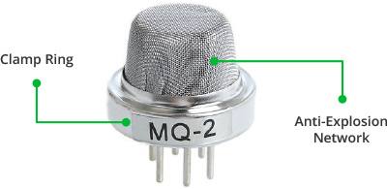

It also provides protection for the sensor and filters out suspended particles so that only gaseous elements are able to pass inside the chamber. The mesh is bound to rest of the body via a copper plated clamping ring.

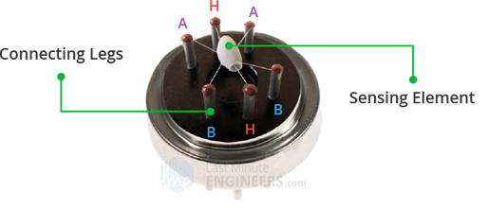

**Figure 4.6: Internal Figure Of MQ-2 Sensor**

This is how the sensor looks like when outer mesh is removed. The star-shaped structure is formed by the sensing element and six connecting legs that extend beyond the Bakelite base. Out of six, two leads (**H**) are responsible for heating the sensing element and are connected through **Nickel-Chromium coil**, well known conductive alloy.

## 4.2.3 Fire Colour Sensor:

The LDR will detect the colour and display it to another RGB LED. Besides display it on the RGB LED, the colour will also display on PC. RGB LED is commonly used in display colours on LCD or OLED such as the monitor and television.

There are actually many methods to detect colour, but using only LED and LDR should be the cheapest way to do this job. Let me explain how this sensor works. First, the LDR has to detect the contrast between black and white surface. To detect the colour, each LED takes turn to shine onto the surface and the Arduino will read the voltage on LDR.

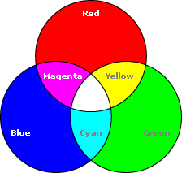

**Figure 4.7: RGB Colour**

I made the Red colour sensor on a piece of strip board. It consists of Red colour LED and Light Dependent Resistor (LDR).

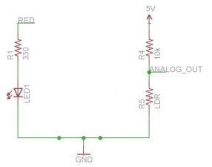

**Figure 4.8 :SCHEMATIC FOR RED COLOUR**

**4.2.4GSM(** Global System for Mobile Communications**):**

GSM is a globally accepted standard for digital cellular communications. GSM uses narrowband Time Division Multiple Access (TDMA) for providing voice and text based services over mobile phone networks.

Listed below are the features of GSM that account for its popularity and wide acceptance.

* Improved spectrum efficiency
* International roaming
* Low-cost mobile sets and base stations (BSs)
* High-quality speech
* Compatibility with Integrated Services Digital Network (ISDN) and other telephone company services
* Support for new services

**4.2.4.1 SIM 800 GSM Modem:**

SIM800 is one of the most commonly used GSM module among hobbyists and Arduino community. Even though AT command reference is available with a quick [Google search](https://www.google.com/search?q=sim800+at+commands), it is not very easy for a beginner to properly understand and use Arduino with SIM800. Therefore, this post summarizes how a beginner could interact with SIM800 using Arduino and in few future posts we’ll be going ahead with several other real life use cases discussing how SIM800 can be used with Arduino effectively.

## 4.2.4.2Hardware Overview of SIM800L GSM/GPRS module:

At the heart of the module is a SIM800L GSM cellular chip from SimCom. The operating voltage of the chip is from **3.4V to 4.4V**, which makes it an ideal candidate for direct LiPo battery supply. This makes it a good choice for embedding into projects without a lot of space.

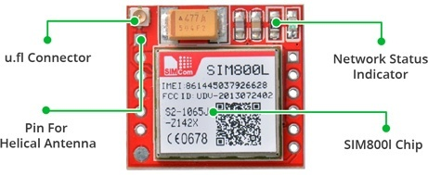

**Figure 4.9: SIM 800 GSM MODEL**

All the necessary data pins of SIM800L GSM chip are broken out to a 0.1″ pitch headers. This includes pins required for communication with a microcontroller over **UART**. The module supports baud rate from **1200bps** to **115200bps** with Auto-Baud detection.

The module needs an external antenna to connect to a network. The module usually comes with a **Helical Antenna** and solders directly to NET pin on PCB. The board also has a U.FL connector facility in case you want to keep the antenna away from the board.

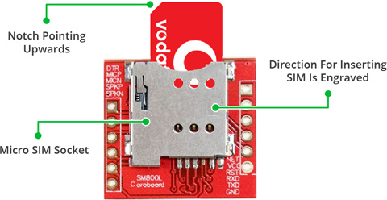

**Figure 4.10: SIM SLOT IN SIM 800 GSM**

There’s a SIM socket on the back! Any activated, **2G micro SIM card** would work perfectly. Correct direction for inserting SIM card is normally engraved on the surface of the SIM socket.This module measures only 1 inch² but packs a surprising amount of features into its little frame. Some of them are listed below:

* Supports Quad-band: GSM850, EGSM900, DCS1800 and PCS1900
* Connect onto any global GSM network with any 2G SIM
* Make and receive voice calls using an external 8Ω speaker & electret microphone
* Send and receive SMS messages
* Send and receive GPRS data (TCP/IP, HTTP, etc.)
* Scan and receive FM radio broadcasts
* Transmit Power:
  + Class 4 (2W) for GSM850
  + Class 1 (1W) for DCS1800
* Serial-based AT Command Set
* FL connectors for cell antennae
* Accepts Micro SIM Card

**4.2.4.3 Circuit Diagram of GSM Transceiver:**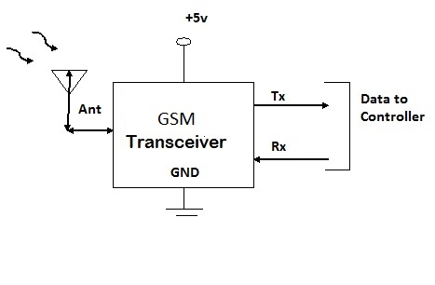

**Figure 4.11: CIRCUIT DIAGRAM OF GSM TRANSCEIVER**

* Circuit diagram of GSM Transceiver device is shown in the figure.
* GSM Transceiver device needs 5v DC supply.
* Receiver pin is connected to AV R Microcontroller.

**4.2.5Buzzer Circuit**

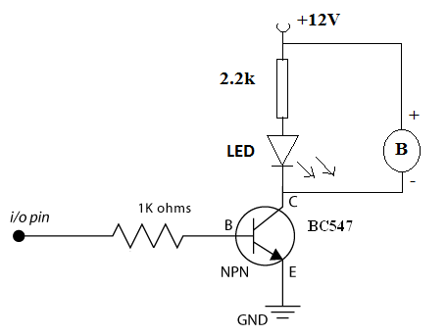

**Figure 4.12: CIRCUIT DIAGRAM OF BUZZER CIRCUIT**

A **buzzer** or **beeper** is a signaling device, usually electronic, typically used in automobiles, household appliances such as a microwave oven, or game shows. It most commonly consists of a number of switches or sensors connected to a control unit that determines if and which button was pushed or a preset time has lapsed, and usually illuminates a light on the appropriate button or control panel, and sounds a warning in the form of a continuous or intermittent buzzing or beeping sound. Initially this device was based on an electromechanical system which was identical to an electric bell without the metal gong (which makes the ringing noise).

Often these units were anchored to a wall or ceiling and used the ceiling or wall as a sounding board. Another implementation with some AC-connected devices was to implement a circuit to make the AC current into a noise loud enough to drive a loudspeaker and hook this circuit up to a cheap 8-ohm speaker. Nowadays, it is more popular to use a ceramic-based piezoelectric sounder like a Sonalert which makes a high-pitched tone. Usually these were hooked up to "driver" circuits which varied the pitch of the sound or pulsed the sound on and off.

**4.2.6Power Supply:**

# Power supply unit consists of Step down transformer, Rectifier, Regulator unit, filters.

# 4.2.6.1 Block Diagram Of Power Supply:

# 

REGULATOR

FILTER

RECTIFIER

(Bridge Rectifier)

STEP DOWN

TRANSFORMER

AC VOLTAGE DC VOLTAGE

**Figure 4.13 : Block Diagram Of Power Supply**

**4.2.6.2 Circuit Diagram Of Power Supply:** 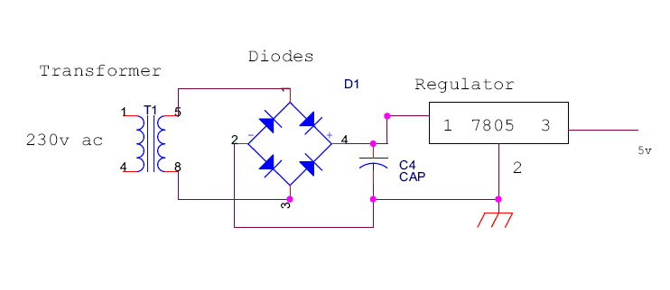

**Figure 4.14: Circuit Diagram Of Power Supply**

**4.2.6.2.1 Step Down Transformer:**

The Step down Transformer is used to step down the main supply voltage from 230V AC to lower value. This 230 AC voltage cannot be used directly, thus it is stepped down. The step down voltage is consists of 12V.The Transformer consists of primary and secondary coils. To reduce or step down the voltage, the transformer is designed to contain less number of turns in its secondary core. The output from the secondary coil is also AC waveform. Thus the conversion from AC to DC is essential. This conversion is achieved by using the Rectifier Circuit/Unit.

**4.2.6.2.2 Rectifier:**

The Rectifier circuit is used to convert the AC voltage into its corresponding DC voltage.

Rectifier having three types,

* Half wave rectifier.
* Full wave rectifier.
* Bridge rectifier.

The most important and simple device used in Rectifier circuit is the diode. This project used to bridge rectifier. A bridge rectifier makes use of four diodes in a bridge arrangement to achieve full-wave rectification. This is a widely used configuration, both with individual diodes wired as shown and with single component bridges where the diode bridge is wired internally.

**[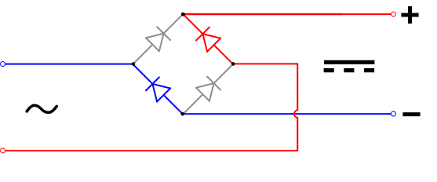](http://en.wikipedia.org/wiki/Image:Diode_bridge_alt_2.svg)**

**Figure 4.15: Bridge Rectifier**

The simple function of the diode is to conduct when forward biased and not to conduct in reverse bias. The Forward Bias is achieved by connecting the diode’s positive with positive of the battery and negative with battery’s negative. The efficient circuit used is the Full wave Bridge rectifier circuit. The output voltage of the rectifier is in rippled form, the ripples from the obtained DC voltage are removed using other circuits available. The circuit used for removing the ripples is called Filter circuit.

The simple capacitor filter is the most basic type of power supply filter. The application of the simple capacitor filter is very limited. It is sometimes used on extremely high-voltage, low-current power supplies for cathode-ray and similar electron tubes, which require very little load current from the supply. The capacitor filter is also used where the power-supply ripple frequency is not critical; this frequency can be relatively high. The capacitor (C1) shown in figure above is a simple filter connected across the output of the rectifier in parallel with the load.

Capacitors are used as filter. The ripples from the DC voltage are removed and pure DC voltage is obtained. And also these capacitors are used to reduce the harmonics of the input voltage. The primary action performed by capacitor is charging and discharging. It charges in positive half cycle of the AC voltage and it will discharge in negative half cycle. Here we used 1000µF capacitor. So it allows only AC voltage and does not allow the DC voltage. This filter is fixed before the regulator. Thus the output is free from ripples.

**4.2.6.2.3 Regulator:**

Regulator regulates the output voltage to be always constant. Regulators is of two types.

* Positive regulator (78XX)
* Negative regulator (79XX)

The output voltage is maintained irrespective of the fluctuations in the input AC voltage. As and then the AC voltage changes, the DC voltage also changes. Thus to avoid this Regulators are used. Also when the internal resistance of the power supply is greater than 30 ohms, the output gets affected. Thus this can be successfully reduced here. The regulators are mainly classified for low voltage and for high voltage. Here we used 7805 positive regulator. It reduces the 12V dc voltage to 5V dc.

The Filter circuit is often fixed after the Regulator circuit. Capacitor is most often used as filter. The principle of the capacitor is to charge and discharge. It charges during the positive half cycle of the AC voltage and discharges during the negative half cycle. So it allows only AC voltage and does not allow the DC voltage. This filter is fixed after the Regulator circuit to filter any of the possibly found ripples in the output received finally. Here we used 0.1µF capacitor. The output at this stage is 5V and is given to the Microcontroller.

**4.2.7Introduction OfArduino Software:**



**Figure 4.16: Arduino Software Symbol**

Arduino is a tool for making computers that can sense and control more of the physical world than your desktop computer. It's an open-source physical computing platform based on a simple microcontroller board, and a development environment for writing software for the board.

Arduino can be used to develop interactive objects, taking inputs from a variety of switches or sensors, and controlling a variety of lights, motors, and other physical outputs. Arduino projects can be stand-alone, or they can be communicate with software running on your computer (e.g. Flash, Processing, MaxMSP.) The boards can b assembled by hand or purchased preassembled; the open-source IDE can be downloaded for free.

The Arduino programming language is an implementation of Wiring, a similar physical computing platform, which is based on the Processing multimedia programming environment.

There are many other microcontrollers and microcontroller platforms available for physical computing. Parallax Basic Stamp, Netmedia's BX-24, Phidgets, MIT's Handyboard, and many others offer similar functionality. All of these tools take the messy details of microcontroller programming and wrap it up in an easy-to-use package. Arduino also simplifies the process of working with microcontrollers, but it offers some advantage for teachers, students, and interested amateurs over other systems:

* Inexpensive - Arduino boards are relatively inexpensive compared to other microcontroller platforms. The least expensive version of the Arduino module can be assembled by hand, and even the pre-assembled Arduino modules cost less than $50
* Cross-platform - The Arduino software runs on Windows, Macintosh OSX, and Linux operating systems. Most microcontroller systems are limited to Windows.
* Simple, clear programming environment - The Arduino programming environment is easy-to-use for beginners, yet flexible enough for advanced users to take advantage of as well. For teachers, it's conveniently based on the Processing programming environment, so students learning to program in that environment will be familiar with the look and feel of Arduino
* Open source and extensible software- The Arduino software is published as open source tools, available for extension by experienced programmers. The language can be expanded through C++ libraries, and people wanting to understand the technical details can make the leap from Arduino to the AVR C programming language on which it's based. Similarly, you can add AVR-C code directly into your Arduino programs if you want to.
* Open source and extensible hardware - The Arduino is based on Atmel's ATMEGA8 and ATMEGA168 microcontrollers. The plans for the modules are published under a Creative Commons license, so experienced circuit designers can make their own version of the module, extending it and improving it. Even relatively inexperienced users can build the breadboard version of the module in order to understand how it works and save money.

# 4.2.8 NEO-6M GPS Module

 NEO-6M global positioning system (GPS) module, a very popular, cost-effective, high-performance GPS module with a ceramic patch antenna, an on-board memory chip, and a backup battery that can be conveniently integrated with a broad range of microcontrollers. Nowadays, two NEO-6M GPS modules are extremely popular — the GY-GPS6MV2 and the GY-GPSV3-NEO.

### ****4.2.8.1 u-blox NEO-6M GPS module****

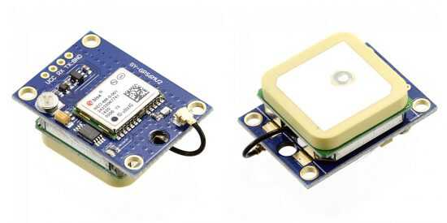

**Figure 4.17: Neo-6m Gps Module**

The u-blox NEO-6M GPS engine on these modules is quite a good one, and it also has high sensitivity for indoor applications. Furthermore, there’s one MS621FE-compatible rechargeable battery for backup and EEPROM for storing configuration settings. The module works well with a DC input in the 3.3- to 5-V range (thanks to its built-in voltage regulator).

* + 1. **Atmega 328 Arduino Microcontroller Circuit:**

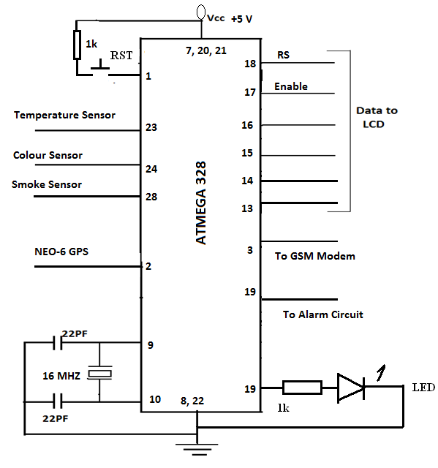

**Figure 4.18 : ATMEGA 328**

* Circuit Diagram of Microcontroller section is shown in the figure.
* Here we are using ATMEGA8L Microcontroller IC.
* Microcontroller uses 16 MHZ crystal oscillator. Pin no 9 and 10 are used to connect the crystal.
* Pin no 1 is reset pin. 1k Resistor and push button switch.
* Pin 7 20 and 21 is Vcc and pin no 8 and 22 is Ground.
* Pins 4 5 6 11 17 and 18 are connected to LCD display pins.
* Sensors are connected to Analog I/O ports.
* AVR Microcontroller calling as master of the project. AVR Microcontroller receives the signal from sensors, processes the data accordingly later displays the message on LCD display and Send the message to control unit Mobile.

**4.2.10 LCD DISPLAY:**

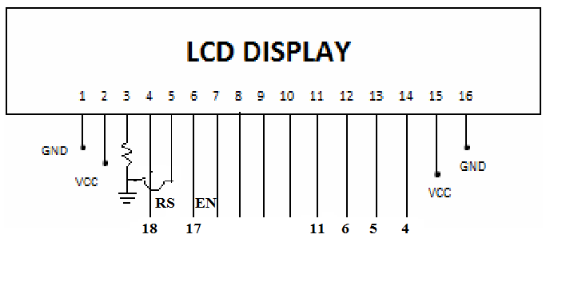

**Figure 4.19: Pin Diagram Of LCD Display**

* In LCD Display pins 1and 16 are Ground. Pins 2 and 15 are Vcc.
* Pins no 3 is used for to adjust voltage contract of LCD display by adding one Variable resistor.
* Pins 4 is use to Reset the LCD.
* Pin 5 is used to Read/Write operations.
* Pins6 is used to enable the LCD.
* For data communication purpose we used 8 pins . They are 7, 8, 9,10, 11,12,13,14 pins.

LCD display is used for display purpose.

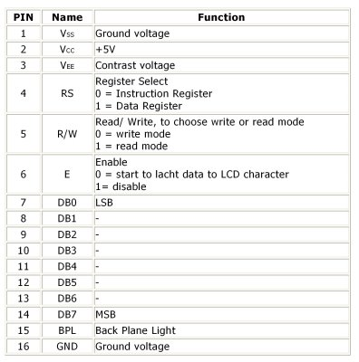

**Table 3: Pin details of LCD display**

**4.3 SOFTWARE**

The software that is used to program the microcontroller, is open-source-software and can be downloaded for free on www.arduino.cc. With this “Arduino software” you can write little programs witch the microcontroller should perform. This programs are called “Sketch”. In the end the sketches are transferred to the microcontroller by USB cable. More on that later on the subject “programming”

**4.3.1 Installation**

Now one after another the Arduino software and the USB driver for the board have to be installed.

**4.3.1.1 Installation and set up of the Arduino software**

1. Download the Arduino software on www.arduino.cc and install it on the computer (The microcontroller NOT connected to the PC). After that you open the software file and start 6 the program named arduino.exe.

Two set ups on the program are important and should be considered.

* 1. 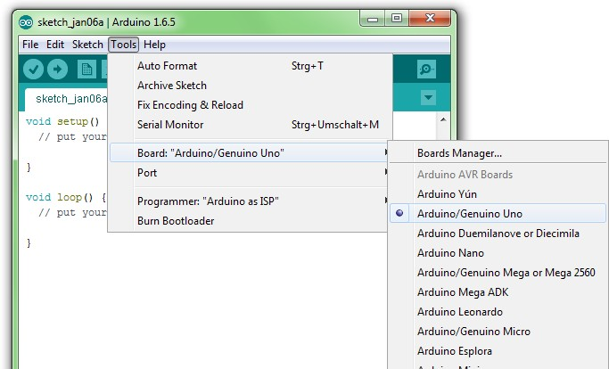The board that you want to connect, has to be selected on the arduino software. The “Funduino Uno” is here known as “Arduino / Genuino Uno”.

**Figure 4.20:selection of Arduino software**

b)Youhave to choose the right “Serial-Port”, to let the Computer know to which port the board has been connected. That is only possible if the USB driver has been installed correctly. It can be checked this way:

At the moment the Arduino isn't connected to the PC. If you now choose “Port”, under the field “Tool”, you will already see one or more ports here (COM1/ COM2/ COM3…).

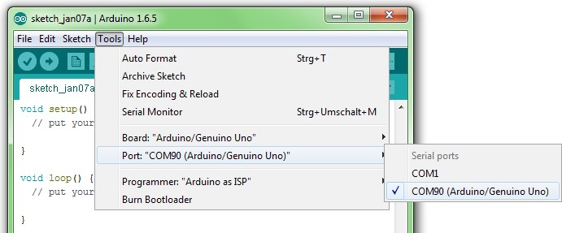The quantity of the shown ports doesn't depend on the quantity of the USB ports on thecomputer.

#### Installation of the USBdriver

How it should be:

1. You connect the board to thecomputer.
2. The Computer recognizes the board and suggests to install a driverautomatically.

ATTENTION: Wait a second! Most of the time the computer can't find the driver automatically to install it. You might choose the driver by your own to install it. It can be found in the Arduino file under “Drivers”.

Control: At the control panel of the Computer you can find the “Device manager”. If the board has been installed successfully, it should appear here. When the installation has failed, there is either nothing special to find or you will find an unknown USB Device with a yellow exclamation mark. In this case: click on the Unknown device and choose update USB Driver. Now you can start over with the manual installation.

* 1. **PROGRAMMING**

Now we can start properly. Without to much theoretical information we start directly with programming. Learning by doing. On the left side you can find the “sketches”, on the right the accompanying explanation for the commands in grey. If you work trough the tutorials with this system, you will soon understand the code and be able to use it by yourself. Later on you can familiarize yourself with other features. These tutorials are only meant as first steps to the Arduino world. All possible program features and codes are referred on [www.arduino.cc](http://www.arduino.cc/) under.

First of all a short explanation for possible error reports that can appear while working with the Arduino software. The two most common ones are:

1)The board is not installed right or the wrong board is selected. After uploading the sketch, there will appear an error report underneath the sketch. It looks like the one in the picture on the right. The note “not in sync” shows up in the error report.

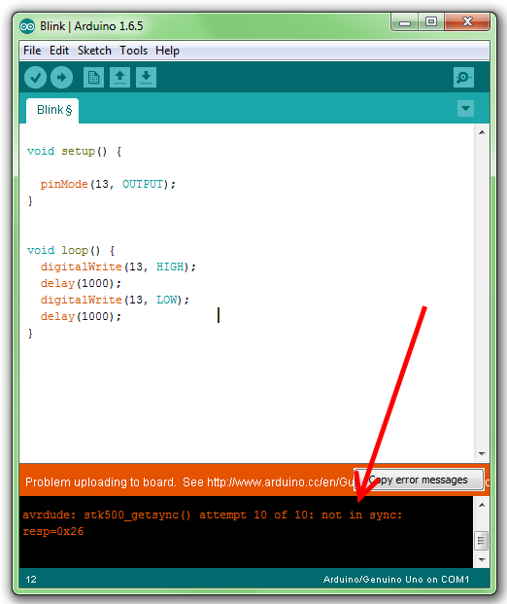

**Fig 4.21:programming section1**

2) There is a mistake in the sketch.For example, a word is misspelled or a bracket is missing. In the example on the left the last semicolon in the sketch is missing. In this Case the error report often starts with “excepted..”. This means that the program is still expecting something that is missing.

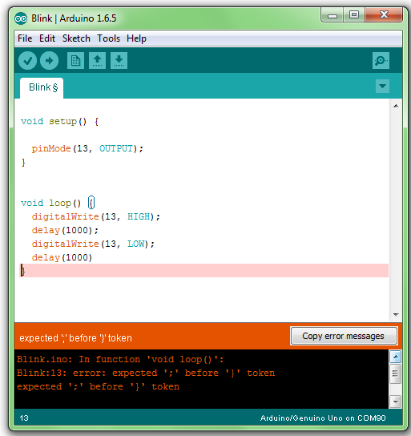

**Fig 4.22: programming section2**

**4.5BASIC STRUCTURE OF A SKETCH:**

A sketch can be divided in three parts:

1)Namevariable: In the first part elements of the program are named.

2)Setup: The Setup will be performed only once. Here, you are telling the program .For Example, what pin should be input and what should be an outputs on boards.

3)Loop: This Loop part will be continuously repeated by the board.

### ****How to Use ATMega328P using Arduino****

Since **ATmega328P** is used in [Arduino Uno](https://components101.com/microcontrollers/arduino-uno) and [Arduinonano](https://components101.com/microcontrollers/arduino-nano) boards, you can directly replace the arduino board with ATmega328 chip. For that first you need to install the **Arduinobootloader** into the chip (Or you can also buy a chip with bootloader – ATMega328P-PU). This IC with bootloader can be placed on Arduino Uno board and burn the program into it. Once Arduino program is burnt into the IC, it can be removed and used in place of Arduino board, along with a Crystal oscillator and other components as required for the project. Below is the **pin mapping between Arduino Uno and ATmega328P chip**.

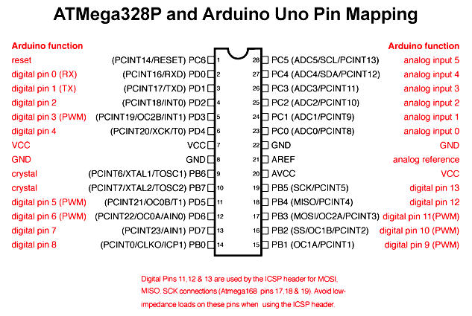

**Figure 4.23: Pin diagram ATMEGA328**

### ****Applications****

There are hundreds of applications for ATMEGA328P:

* Used in ARDUINO UNO, ARDUINO NANO and ARDUINO MICRO boards.
* Industrial control systems.
* SMPS and Power Regulation systems.
* Digital data processing.
* Analog signal measuring and manipulations.
* Embedded systems like coffee machine, vending machine.
* Motor control systems.
* Display units.
* Peripheral Interface system.

**4.6 HARDWARE AND SOFTTWARE REQUIREMENTS**

**4.6.1 Hardware Requirement:**

* AVR Microcontroller
* Fire Sensor
* LCD Display
* GPS Modem
* GSM Modem
* Alarm Circuit Board
* Power Supply
* Mobile(Your Mobile)

**4.6.2 Software Requirement:**

* Arduino Software
* Embedded C

**4.7APPLICATIONS**

* It can be used in forest areas.
* It can be used in industries.
* It can be used in educational areas.
* It can be used in power station.
* It can be used in public sectors servicing areas.
* It can be used in military.
* It can be used in home.

**4.8ADVANTAGES AND DISADVANTAGES**

**4.8.1 ADVANTAGES**

* Complexity is reduced due to wireless communication protocol.
* It is reprogrammable device.
* AVR Microcontroller provides digital output. So that It provides good accuracy.
* It saves nature property from getting damage.
* It saves animals and human life.
* It is a low power device.

**4.8.2 DISADVANTAGES**

* The range of a wireless network is limited.
* Insufficient of power supply.
* Lack of network in dense forest.

**CHAPTER 5**

**RESULTS**

The model consist of AVR microcontroller, LCD display, LM35 as temperature sensor, MQ2 as Smoke sensor, RGB as Color sensor, GPS Module and SIM800 as GSM. The Red color indicates that AVR Microcontroller is functioning.

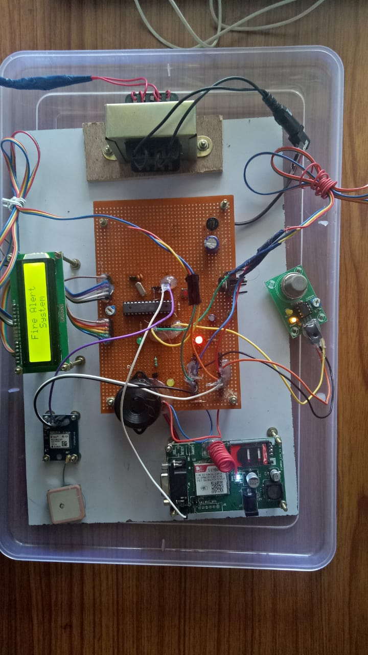

**Fig 5.1: Model Of Forest Fire Prediction Using Wireless Network**

In the Forest , when the temperature becomes high, theLM35 sensor senses the temperature and send the message to the respective mobile through GSM. Then, When the Fire is found at forest the sensors senses the respective parameters and sends the message and display at LCD and sounds the Buzzer.

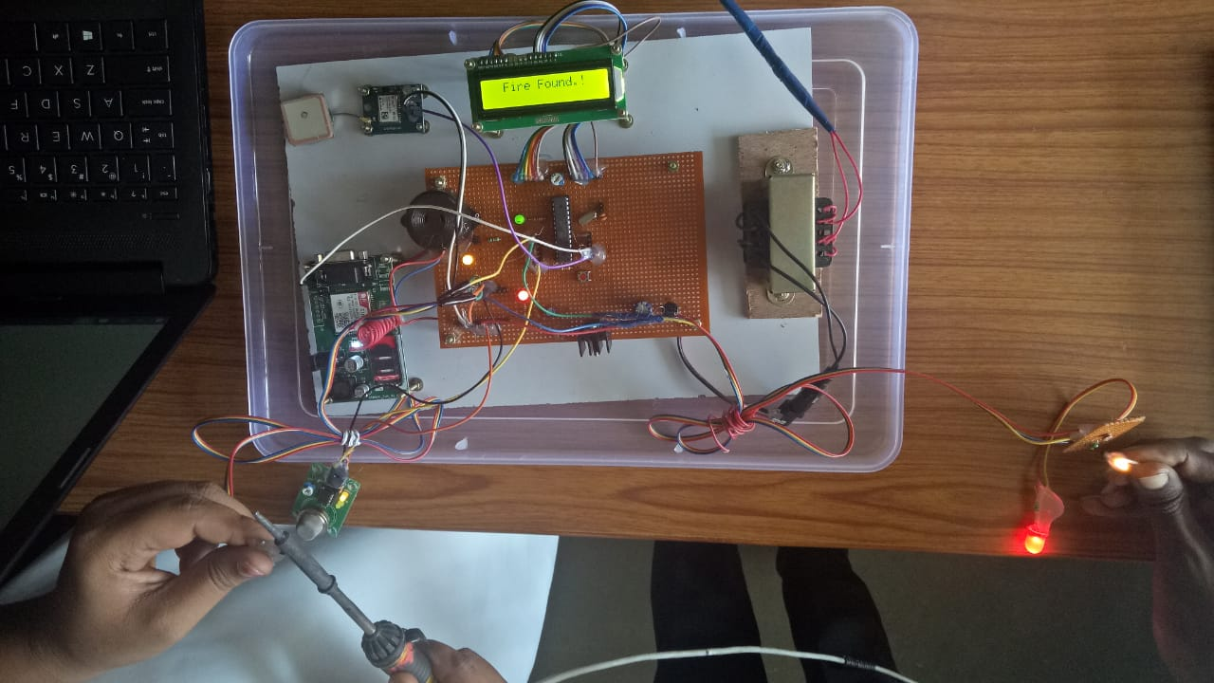

**Fig 5.2: Output of forest fire**

When the sensor senses the respective parameters, the message is send as”FIRE FOUND IN FOREST AREA” with location through GSM and GPS respectively to respective mobiles.

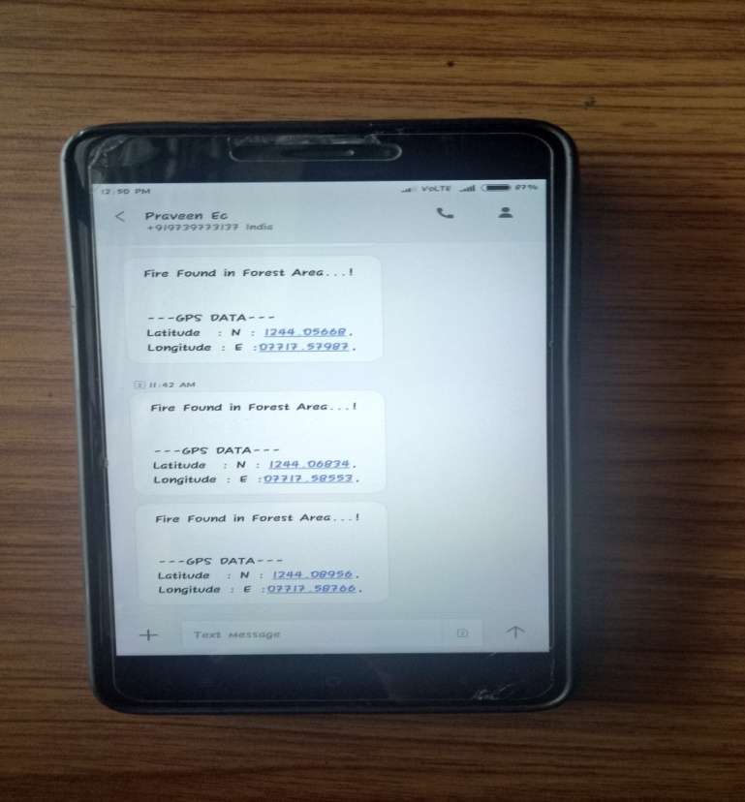

**Fig 5.3: Message Sent To Respective Mobile**

**CHAPTER 6**

**TESTING**

The purpose of testing is to discover errors. Testing is the process of trying to discover every conceivable fault or weakness in a work product. It provides a way to check the functionality of components, sub assemblies, assemblies and/or a finished product It is the process of exercising software with the intent of ensuring that the

Software system meets its requirements and user expectations and does not fail in an unacceptable manner. There are various types of test. Each test type addresses a specific testing requirement.

# 6.1 Integration Testing

Software integration testing is the incremental integration testing of two or more integrated software components on a single platform to produce failures caused by interface defects.

The task of the integration test is to check that components or software applications, e.g. components in a software system or – one step up – software applications at the company level – interact without error.

**Test Results:** All the test cases mentioned above passed successfully. No defects encountered.

**6.2 Acceptance Testing**

User Acceptance Testing is a critical phase of any project and requires significant participation by the end user. It also ensures that the system meets the functional requirements.

**Test Results:** All the test cases mentioned above passed successfully. No defects encountered.

**CONCLUSION**

This Embedded Based automation enable the fire detection and data acquisition process.Wireless protocol provides efficient online monitoring System and sends the message to the police station and forest control room. By this we can predict the place of fire & save the wild life.

**FUTURE ENHANCEMENT**

* Since we are using Embedded system, it covers small distance which is unable to cover the wide range of Forest. So, This Project can also be done by using Digital Image Processing, which can cover large distance of Forest area.
* By Using the IOT technology, we can store the data base of forest fire.
* By Using the Advanced and Real time sensors we can get Accuracy and efficiency result.

**REFERENCES:**

[1] T. Akyildiz, W. Su, E. Cayirci, and Y. Sankarasubramaniam, "A survey on sensor networks," in proc. of IEEE Communications Magazine, vo1.40, no. 8, pp. 102-114, Aug.2002.

[2] C. F. Garcia Hernandez, P. H. Ibargliengoytia-Gonzalez, J. , J.A. Perez Diaz and Garcia Hernandez," Wireless Sensor Networks and Applications a Survey," International Journal of Computer Science and Network Security, vo!.7 no. 3, Mar. 2007.

[3] A. Mainwaring, D. Culler, R. Szewczyk, and J. Anderson."Wireless sensor networks for habitat monitoring", In Proc. of the First International Workshop on Wireless Sensor Networks and Applications (WSNA'02), pages 88-97, Atlanta, Georgia, Sep. 2002.

[4] Ajay V. ,Chetan B., Ganesh S., Kumaran S., “Sensor Nodes Approach to Forest fire Prediction and Prevention,” Stony Brook University, 2009

[5] Stipaničev, D., et al., “Forest Fire Protection by Advanced Video Detection System- Croatian Experiences” Split, Croatia, 2006.

[6] D. M. Doolin and N. Sitar, "Wireless Sensor Nodes for Wildfire Monitoring", SPIE Symposium on Smart Structures and Materials, San Diego, pp. 477484, 2006

[7] D. Morvan, M. Larini, J. L. Dupuy, A. 1. Iranda, J. Andre, O. Sero-Guillaume, P. Cuinas, "Behavior Modeling of Wild land Fires: A State of the Art", EUFIRELAB: Euro-Mediterranean Wild land Fire Laboratory, 2002.

[8] Wikipedia, the free encyclopedia, RS-232, [Online], Available at: <http://en.wikipedia.org/wiki/RS-232>.

[9] Multiparameter fire detection based on wireless sensor network by S Liu, D Tu, Y Zhang and intelligent systems,2009

[10] Monitoring system for forest fire based on wireless sensor network by Yingli Zhu